Press release
Prague - Kyiv, March 16, 2022.

Solidarity is more than a word…
While the war in Ukraine is continuing the Veolia community in Ukraine and CEE is more united than ever. Here are a few highlights:
- The three Veolia companies in Ukraine are continuing to work under war conditions. While the companies in the Western Ukraine (Ternopil and Chernivtsi) are working on full capacity, our largest company in Kyiv is providing waste collection and cleaning services with up to 18 collection tours and additional hook lift trucks – despite of fights and bomb and rocket attacks in and all around Kyiv. All these colleagues are real heroes at the waste front!
- While men between 18 and 60 years old cannot leave Ukraine, many of our employees decided to send their families to safer places. Consequently, more than 50 women and children crossed the border to neighbor countries, were welcomed and accommodated by the Veolia teams.
  - The Polish HR team made several nightshifts to safely guide our Ukrainian colleagues through the borders, arrange accommodation and transport after crossing the border.
  - German, Slovak and Czech colleagues arranged transportation from the border to Czech Republic, Germany and other countries. Transfer was made by Veolia volunteers who brought our colleagues safely to their final destinations.
  - Accommodation for our Ukrainian families is arranged with the support of the aid@veolia app: Veolia colleagues are proposing accommodation and taking care of our Ukrainian families and the German-Ukrainian team is matching requests and proposals jointly with the HR team, guide the families to their hosts or assign accommodation in hotels, centers or flats. Nobody is left alone and we are taking care of everybody!
- The donation campaign from Veolia employees for Veolia Ukraine colleagues and their families is running very well – almost 50 000 € were donated within less than a week! While some families who arrived to Germany received first financial support, we assume that the larger part of this money will be needed after the war when families will come back and have to rebuild what they lost.
- Many other actions are showing the large engagement of the Veolia family:
  - Taking care of a wounded woman from a partner company who is now receiving medical treatment in Poland.
  - Different campaigns of collection of medicine, food and goods for further delivery to Ukraine.
  - Technical support with equipment for the district heating company in Kyiv and similar actions.
Solidarity is more than a word… It’s continuing services under most difficult conditions, taking care of our Ukrainian colleagues and their families, personal involvement, empathy, night shifts and financial donations – these are proven values of our Veolia community!
#staywithukraine #veolia #staystrong #tellthetruth

Some photos – see the next page ----------------

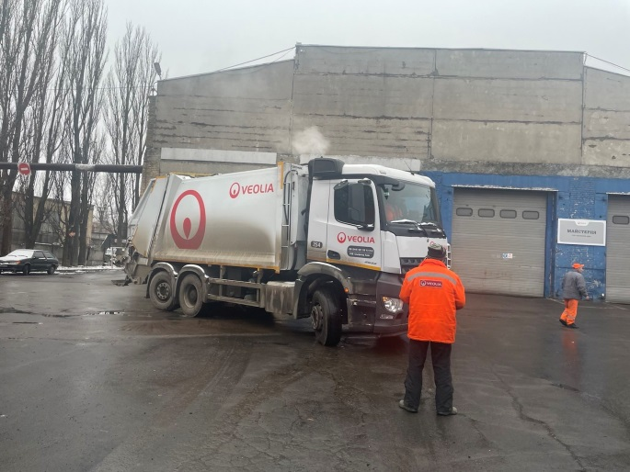
Waste truck at shift start in Kyiv

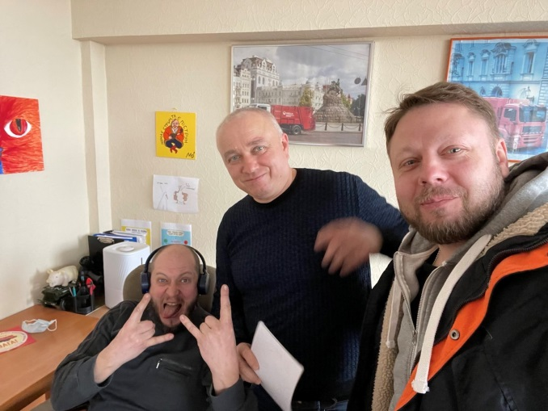
Veolia Kyiv shift on duty - even under most difficult conditions

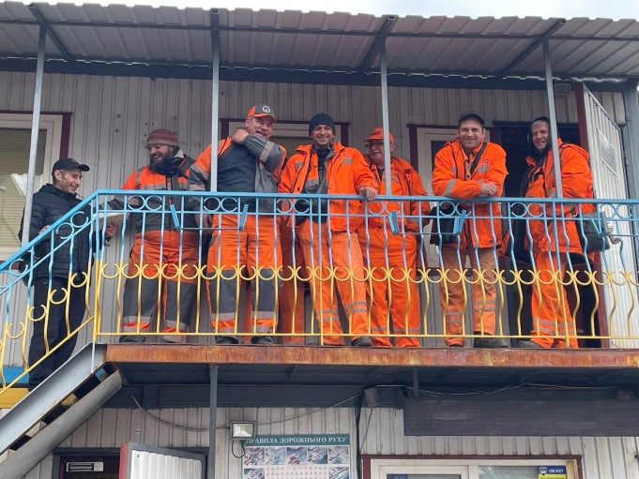
Waste heroes after the shift

