Press release
September 30th 2015

Veolia Ukraine participated to the biggest sporting event of the year - Wizz Air Kyiv Marathon 2015.

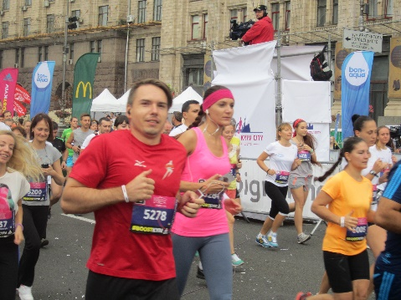 |  | 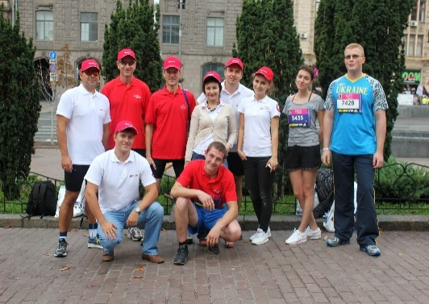 |  | 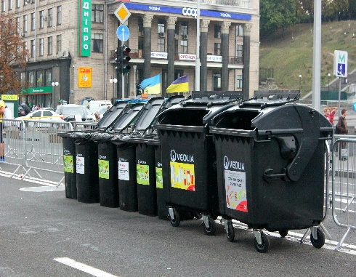

On September 27th the capital of Ukraine received the biggest running event of the year, the 6th International marathon «Wizz Air Kyiv City Marathon 2015». This high-class event tested again our athletes and sport amateurs on the streets of the capital. This time the marathon gathered together on Independence square near 3 800 athletes from 34 countries.

In addition to the classic marathon distance of 42,195 km the runners partcipated to two relays (2 x 10 + 2 x 11.0975 km and 2 x 21.0975 km), races of 10 & 5 km, and the charity race of 2 km - "Run and Help". Through charitable contributions of participants the organizers managed to gather more than 830 000 UAH to assist orphanage, hospitals and shelters.

Veolia Ukraine company supported Kyiv International Marathon 2015 as an eco-partner ensuring separate collection and disposal of solid waste.

Passion to the sport activities and the desire to establish its own record led to Independence Square some staff members of Veolia Ukraine company: Alexander Korolyuk, Pavel Grigoriev, Viktor Sypchenko and Alexey Melnychuk.
We are very proud of our colleagues and believe in their victory next year!

********************************************************************************************************************************
Veolia has been operating in Ukraine since 1995 in the waste management area which represents a core business line on the local market. Today Veolia Ukraine is managing activities through four subsidiaries located in Kyiv, Ternopil, Chernivtsi and Yalta.

For any additional information please consult the web-site www.veolia.ua.
...

Contact
Olga Nikulina
Tel. : + 38 (095) 272 23 58
olga.nikulina@veolia.com

